## Notes on USDA API usage

5/16/21 - Danny Graziano

I’ve begun looking into how the USDA API works for getting nutritional information from various foods. The good news is that it seems pretty extensive in the data that’s available. Gaining access is easy, you just enter your email address in the “Gaining Access” link here: <https://fdc.nal.usda.gov/api-guide.html>

This will give you a custom API token to use with your requests. Here is an example of a request I made with my key for Apple:

<https://api.nal.usda.gov/fdc/v1/foods/search?query=apple&pageSize=2&api_key=><YOUR_API_KEY_HERE>

Make sure you replace <YOUR_API_KEY_HERE> with the key you get from the sign up page.

You’ll get JSON response back with results for each food that came up in the search. They will all be structured in a nested JSON format, so we just have to traverse to the key labeled as “Energy” and extract the VALUE:

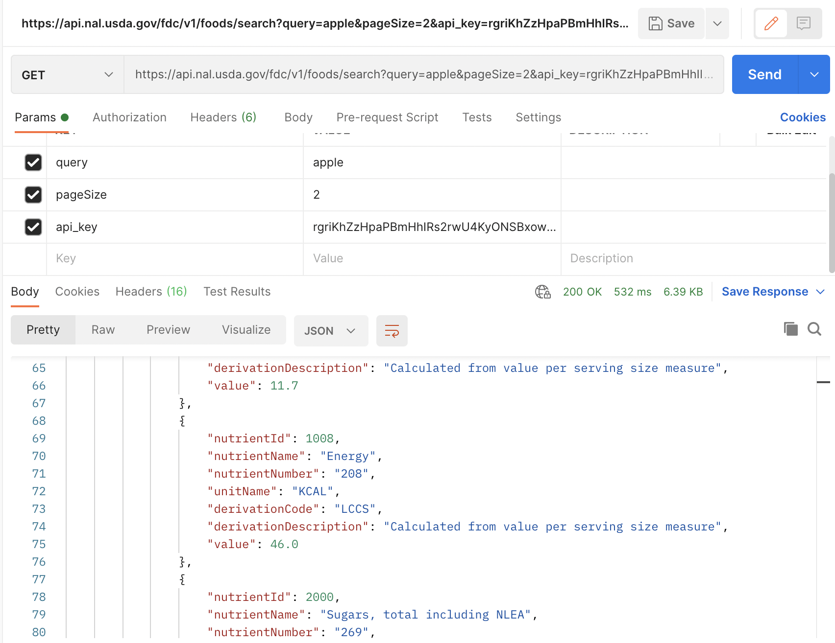

### Follow up questions:

* Whose API key will we use for the final app? We should not store the key directly in the code that will go to github because this is a security risk, what is the right thing to do instead in terms of security?
* Multiple entries are present for each product searched. Should we take the top result, or average the top 50?
* Food weight doesn’t seem to be included here, how do we scale the calories for the case where someone eats only a portion of the item?
* Note on units: it seems like entries can be in cal/Kcal or Joule/kJ (for imported products using SI units). We will just need to make sure to take note of the recorded units, and perform a conversion for displaying it correctly to the user. Should a requirement be that the user can select whether they want to view in Calories or kJ?